**NOT recommended use the botox** and **Blow the table** , Botox is NOT used in food animals like sheep, goats, or cattle due to high toxicity

**External Parasites in Sheep**

**Sheep Ked (Melophagus ovinus)**

* Found mainly on neck, breast, shoulder, flank, and rump.
* These wingless flies stay in fleece and feed on blood.

🐜 **Mites (e.g., mange mites)**

* Burrow into the skin causing intense itching and scabs, commonly around ears, face, neck, shoulders, and less-wooled areas.

**Ticks**

* Preferred sites: legs (especially below the fetlock joint), head and ears, belly, around the tail, groin.
* They embed mouthparts deeply to feed on blood.

🐜**Lice**

* Often on skin of the neck, brisket, shoulder, back, and rump.
* Biting lice feed on skin debris; sucking lice may cling closer to skin folds.

Do not use Botox without watching this video **Extremely Dangerous**

**Video link** **:https://srikanthmekala500.github.io/my-website-Sheep/**

|  |  |  |  |  |
| --- | --- | --- | --- | --- |
| **Parasite** | **Key Symptoms** | **Drug** | **Dose** | **Repeat** |
| icks | Anemia, fever, wounds | Ivermectin (inj) | 0.2 mg/kg SC | 10–14 days |
| Ticks | Visible ticks | Deltamethrin (pour-on) | As per label | 7–14 days |
| Lice | Severe itching, wool loss | Ivermectin (inj) | 0.2 mg/kg SC | 10–14 days |
| Lice | Same | Cypermethrin spray | As per label | 7–10 days |
| Mange mites | Scabs, hair loss, intense itching | Ivermectin (inj) | 0.2 mg/kg SC | 7–10 days |
| Mange mites | Chronic cases | Amitraz dip | As per label | 7–10 days |
| Sheep ked | Anemia, wool damage | Ivermectin (inj) | 0.2 mg/kg SC | 10–14 days |
| Sheep ked | Same | Cypermethrin dip/spray | As per label | 7–10 days |
| Fleas | Itching, skin irritation | Cypermethrin spray | As per label | 7–10 days |
| Lice + Ticks (mixed) | Pruritus, poor growth | Doramectin (inj) | 0.2 mg/kg SC | 14 days |

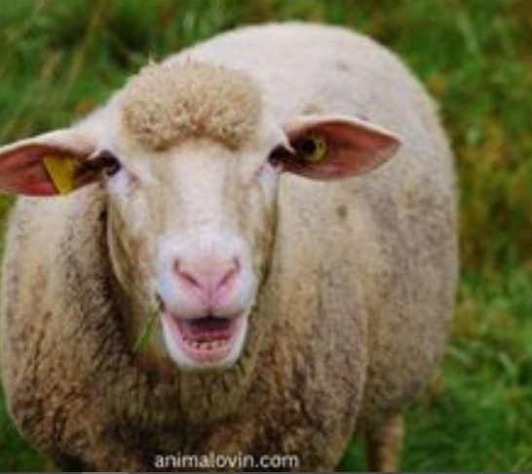

**Treatment for Cough in sheep**

Treatment

**Preferred Oral Options (choose ONE)**

Use **only one syrup**, not all together:

1. **Levofloxacin hemihydrate + Bromhexine HCl**
2. *(Meriflox / similar)*
3. **Enrofloxacin + Ambroxol HCl**
4. *(Meriquin-AX)*
5. **Terbutaline sulphate + Ambroxol + Guaiphenesin + Menthol syrup**
6. 👉 Best choice if cough is **dry / allergic**

⏱ Duration: **3–5 days**

**1️⃣ Respiratory Infections**

* **Bacterial**: *Pasteurella multocida*, *Mannheimia haemolytica* → Pneumonia
* **Viral**: Parainfluenza 3, Sheep Pox (respiratory form)
* **Signs:** Coughing, nasal discharge, fever, labored breathing

**2️⃣ Parasitic**

* **Lungworms**: *Dictyocaulus filaria* (common in young sheep)
* **Signs:** Dry or moist cough, weight loss, difficulty breathing, moist rales

**3️⃣ Environmental / Irritant**

* Dusty feed, moldy fodder, ammonia in sheds
* Sudden cold, wet weather exposure

**Doctor-Recommended Injectable Option**

If cough persists:

* **Enrofloxacin + Bromhexine HCl injection**
* ⏱ **3–5 days**

**PLUS (choose one):**

* Injection **Chlorpheniramine Maleate**– 3 days **(OR)**
* **Tysin-100 injection**

🌿 **If NO fever + NO cold → Likely ALLERGY**

Use this **supportive therapy**:

* **Caflon powder**
* 👉 15 g morning + 15 g evening
* ⏱ 3–5 d ays

✔ Very useful for dust, pollen, feed allergy

**Second Stage (ONLY if condition worsens)**

*(Deep cough, breathing difficulty)*

* **Inj. Xceft (Ceftiofur)** – **4 mg/kg**
* **Inj. Prednisolone** – **2–3 ml**
* **Inj. Zeet (CPM)**

⏱ **3–5 days**

⚠️ Use steroids **only when necessary**

**Medicine and Video images are available in website**

**https://srikanthmekala500.github.io/my-website-Sheep/**

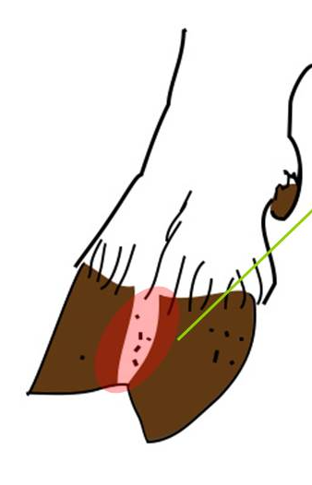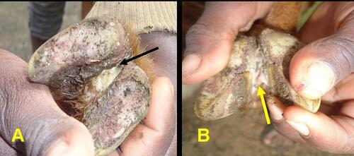

##### **Foot Rot in Sheep**

### **1. Cause**

Foot rot is a **contagious bacterial disease** mainly caused by:

* **Dichelobacter nodosus** (primary cause)
* **Fusobacterium necrophorum** (secondary, helps infection start)

**Predisposing factors (common in India):**

* Wet and muddy conditions (monsoon season)
* Poor drainage in sheds
* Injuries or softening of skin between claws
* Overstocking and poor hygiene

**Medicine images and Videos are available in website**

**https://srikanthmekala500.github.io/my-website-Sheep/**

**Treatment**

### **Foot bath / Dressing**

**Most effective:**

* **Zinc sulfate 10% solution**
  + Stand sheep for **10–15 minutes**
* OR **Copper sulfate 5% solution**

### ✅ **Use SEPARATELY, not together**

**Step 1 (only if foot is very dirty or full of pus):**

* Use **hydrogen peroxide 3% once only**
* Let it foam
* **Rinse well** with clean water or saline

**Step 2 (after cleaning):**

* Apply **povidone-iodine (1–2%)**
* Allow to dry

**Step 3 (next days):**

* Use **only povidone-iodine**, once daily

## **Clinical Signs**

* **Lameness** (mild to severe)
* **Redness and swelling** between the claws
* Moist, greyish or whitish **interdigital skin**
* **Foul-smelling discharge**
* **Separation of hoof horn** from soft tissue (starting at heel)
* Pain, heat in the foot
* Sheep walk slowly, kneel, or avoid movement
* Reduced grazing, **weight loss**
* Chronic cases: **deformed, overgrown hoove**

### **Antibiotic treatment (vet prescribed)**

Use **systemic antibiotics** in moderate to severe cases:

* **Enrofloxacin**
* OR **Oxytetracycline (long-acting)**
* OR other vet-recommended antibiotics

### **. Pain and inflammation control**

* **Flunixin meglumine** or **Meloxicam**
* Usually **1–3 days** is enough
* Helps sheep walk, eat, and recover faster

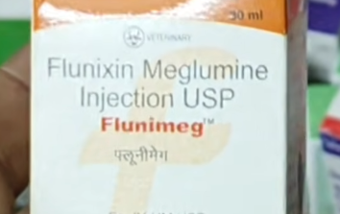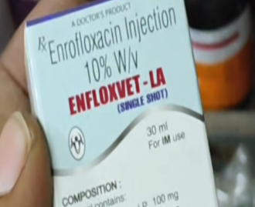

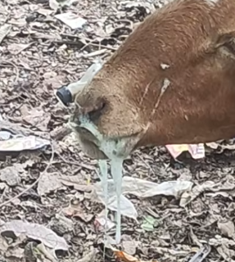

**Medicine images and Videos are available in website**

**https://srikanthmekala500.github.io/my-website-Sheep/**

**Treatment**

## **Stage 1 – Mild / Early Pneumonia**

**Drugs & Purpose**

* **Tylosin (10 mg/kg, 3–5 days)** → antibiotic for mild bacterial infection
* **Meloxicam (1 ml/30 kg, 2 days)** → fever and inflammation control
* **Zeet syrup (2–3 ml, 5 days)** → expectorant to ease breathing

**Use:**  
✅ Only for **mild signs**: cold, mild cough, low fever, slight lethargy

**Key Rule:**

* Monitor for **24–48 hours**
* If no improvement → move to Stage 2

### **Clinical Signs**

**Typical pneumonia:**

* Fever
* Cough (dry or moist)
* Nasal discharge (serous or mucopurulent)
* Rapid breathing (tachypnea)
* Open-mouth breathing in severe cases
* Loss of appetite, lethargy
* Poor growth, weight loss

**Silent pneumonia:**

* Pneumonia **without obvious signs of illness**
* Sheep **appear healthy**, no cough, normal breathing
* Often detected only during **slaughter, necropsy, or X-ray**
* Can cause **reduced growth and production**
* Common in **young lambs** or **chronic cases**

# **Pneumonia Treatment in Sheep**

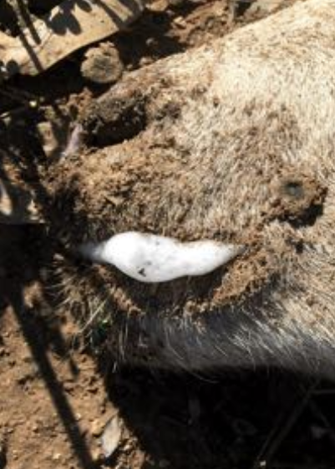

## **Silent Pneumonia – Definition**

* Lung infection **without obvious clinical signs**
* Sheep appear **healthy** externally
* Often **missed during routine observation**
* Can still cause **reduced growth, poor weight gain, and production loss**

## **Stage 2 – Severe Pneumonia (Advanced)**

**Drugs & Purpose**

* **Ceftiofur Sodium (1–2 mg/kg, 3–5 days)** → strong antibiotic for severe infection
* **Flunixin Meglumine (1 ml/45 kg, 2–3 days)** → strong fever & pain relief
* **Pheniraine Maleate / Avilin (1–2 ml, 2–3 days)** → anti-histamine for respiratory relief

**Use:**  
✅ Only if Stage 1 **fails** or if sheep shows:

* High fever
* Thick nasal discharge
* Open-mouth breathing
* Weakness, not eating

**Important Rules:**

* **Do NOT mix Stage 1 and Stage 2 on the same day**
* **Do not give Meloxicam and Flunixin together**
* Do not switch antibiotics daily

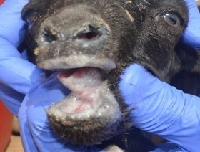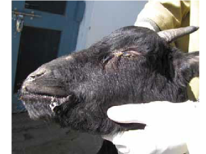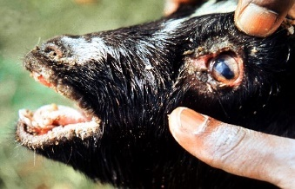

**PPR in Sheep**

**Medicine images and Videos are available in website**

**https://srikanthmekala500.github.io/my-website-Sheep/**

A highly contagious viral disease of sheep and goats caused by **PPR virus**, characterized by **fever, mouth lesions, diarrhea, and respiratory signs**.

|  |  |  |
| --- | --- | --- |
| Stage | Symptoms | Treatment Indication |
| Stage 1 – Mild / Early | Mild fever, watery nasal discharge, mild cough, eating reduced but still active | Use mild antibiotics + fever control (Tylosin + Meloxicam + Expectorant) |
| Stage 2 – Severe / Advanced | High fever, thick nasal discharge, fast breathing, weakness, not eating, no improvement after 24–48 hrs of Stage 1 | Use strong antibiotics + anti-inflammatory (Ceftiofur + Flunixin + Pheniraine) |

## **Key Symptoms of PPR in Sheep**

* **High fever** – 5–8 days, often first sign
* **Nasal & ocular discharge** – watery → thick/pus-like
* **Mouth lesions** – ulcers/erosions on lips, gums, tongue
* **Respiratory distress** – coughing, labored breathing, pneumonia
* **Diarrhea** – severe, foul-smelling, dehydration
* **Depression & anorexia** – weak, lethargic, stop eating
* **Sudden death** – especially in goats (mortality up to 80%)
* **Abortions** – in pregnant animals

**Stage 1 – Mild / Early Pneumonia**

**Stage 2 – Severe Pneumonia**

**Treatment Protocol:**

1. **Enrofloxacin Injection (Fortivir – Virbac)**
   * **Dose:** 5–10 mg/kg IM
   * **Duration:** Once daily for 3–5 days
   * **Purpose:** Antibiotic to treat mild bacterial infection
2. **Meloxicam Plus**
   * **Dose:** 1 ml per 30 kg
   * **Duration:** 2 days
   * **Purpose:** Reduces **fever, inflammation, and pain**
3. **Zeet Injection / Syrup**
   * **Duration:** 5 days
   * **Purpose:** Helps relieve **cough and mucus**

• **Ceftriaxone Injection (Intacef – 0.5 g)**

* **Dose:** 10–20 mg/kg IM
* **Preparation:** Mix with sterile water
* **Duration:** Once daily for 3–5 days
* **Purpose:** Strong antibiotic for severe bacterial lung infection

• **Meloxicam Plus**

* **Dose:** 1 ml per 30 kg
* **Duration:** 2 days
* **Purpose:** Reduces **fever and lung inflammation**

• **Zeet Injection / Syrup**

* **Duration:** 5 days
* **Purpose:** Helps relieve **cough and aids breathing**

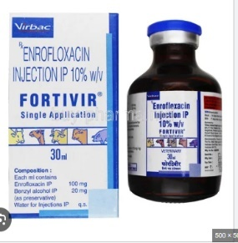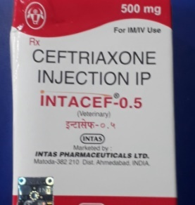

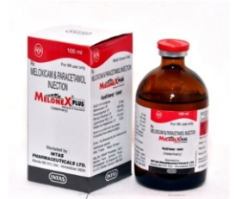

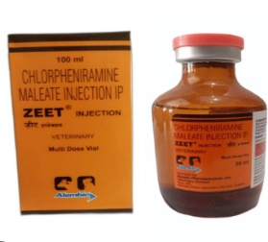

##### **Blue Tongue**

**Medicine images and Videos are available in website**

**5. Swollen / Damaged Gums**

* **B-Complex Injection (Tribivet)** – 3 ml IM (or weight-based as per label)  
  **Frequency:** Usually once daily, can give in morning or evening.

**6. Mouth Sores**

* **Topicure SG Spray** – apply inside mouth gently  
  *or*
* **Boro-Glycerine** – apply gently inside mouth  
  **Frequency:** 2–3 times daily as needed

**7. Leg / Foot Sores**

* Wash with **Potassium Permanganate (KMnO₄)** solution
* Apply **Topicure Spray** or **D-Mag Spray**  
  **Frequency:** 2 times daily

**1. Antibiotic (Choose ONE for the whole course)**

* **Intacef Injection** – 15 mg/kg IM/IV  
  *or*
* **Dichristrin (Penicillin) Injection** – as per label dose  
  *or*
* **Ceftiofur Sodium** – as per label dose  
  **Frequency:** Typically once or twice daily as per label. Use only **one antibiotic**.

**Bluetongue Signs in Sheep:**

**1. Mouth & Tongue**

* Drooling, swollen lips
* Swollen or blue/purple tongue (30–35% cases)
* Mouth ulcers, difficulty chewing/swallowing  
  **→ Swollen lips + drooling + ulcers = suspect Bluetongue**

**2. Face**

* Swollen face, red eyes
* Nasal discharge, dry/cracked muzzle

**3. Legs & Feet**

* Lameness, swollen coronet
* Redness at hoof line, lying down more

**4. Body Condition**

* Fever, weakness, dullness
* Wool breaks easily, weight loss

**5. Key Indicators (if ≥3 present, likely Bluetongue)**

* Swelling of mouth/head
* Mouth ulcers
* Blue/purple tongue
* Lameness + swollen hooves
* Excess drooling

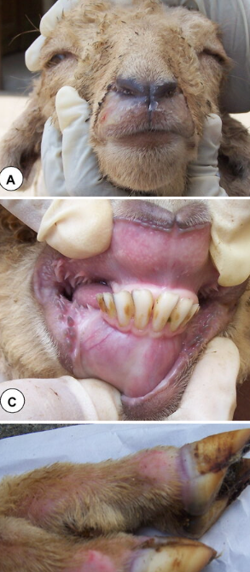

**2. Fever Control**

* **Melonex Plus Injection** – 1 ml per 10 kg  
  *or*
* **Doloban Plus Injection** – 1 ml per 20 kg

**Morning & Evening:** Administer as indicated above.

**3. Limping / Severe Pain**

* **Flunixin Meglumine Injection** – 2 ml per 45 kg  
  **Morning & Evening:** For severe pain or inflammation.

**4. Zeet (Optional in your area)**

* **Zeet Injection** – as per label dose  
  **Morning & Evening:** If available, gives pain relief + fever control + supportive care.

**8. Energy & Hydration Support (Very Important!)**

* **Gluco Boost Powder** – 10–20 g in 1 liter clean water
* **ORS Powder** – 1 sachet in 1 liter water
* **Ragi Java (Ragi Malt)** – 200–300 ml warm, easy-to-digest feed  
  **Frequency:** 1–2 times daily depending on weakness

**9. Prevention – External Parasite Control**

* Amitraz Spray or Dip – as per label instructions  
  **Frequency:** Usually **once or twice a week**, not daily

# **Bottle Jaw**

### **Signs / Symptoms**

* Swelling under the jaw (soft, pitting when pressed)
* Pale eyelids (anemia)
* Weakness, reduced appetite
* Diarrhea (sometimes, depending on worm type)
* Loss of body condition

### **1. Deworming — Choose based on suspected cause**

**Important:** Only give **one type** of dewormer at a time.

**A. Liver Fluke Suspected** (wet fields, marshy grazing):

* **Triclabendazole** – 10 mg/kg, single oral dose
* OR **Closantel sodium dihydrate** – 10 mg/kg, single oral dose

**B. Haemonchus Worm Suspected** (pale eyelids, anemia):

* **Closantel sodium** – 10 mg/kg, single oral dose
* OR **Ivermectin 1%** – 1 ml per 50 kg  
  **Do not combine Ivermectin and Closantel on the same day.**

# **Treatment**

“**Bottle jaw**” in sheep is a **visible swelling under the lower jaw** caused by **fluid accumulation (edema)** in the tissues. It’s not a disease itself but a **sign of underlying problems**, usually related to **parasitic infections or poor nutrition**. Here’s a clear breakdown:

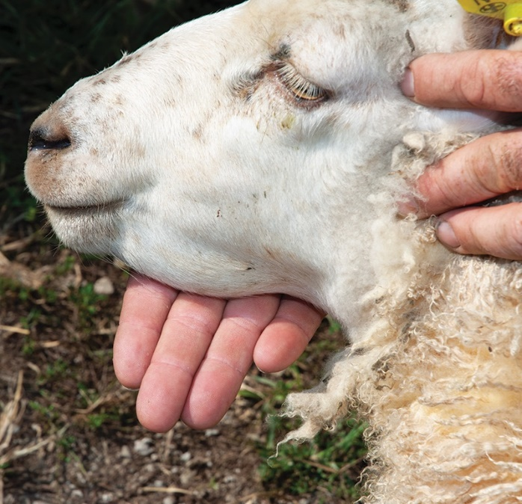

### **Causes of Bottle Jaw**

1. **Parasitic Worms (Most Common)**
   * **Haemonchus contortus** (barber’s pole worm) – causes anemia, low protein
   * Heavy worm infestation → protein loss → fluid collects under the jaw
2. **Protein Deficiency**
   * Lack of high-quality feed or poor nutrition
   * Low blood protein (albumin) → fluid leaks into tissues
3. **Liver Disease / Chronic Illness**
   * Less common, but liver flukes or other chronic infections can contribute

### **3. Bottle Jaw Swelling — Lasix injection (furosemide)**

### **Safe Use Instructions:**

* Give **1 mg per kg body weight** once daily
* Example: 20–25 kg sheep → 20–25 mg Lasix
* Injection: 0.25–0.5 ml IM (20 mg/2 ml vial)
* **Duration:** Maximum 2–3 days only
* **⚠ Important:** Only give if sheep is **hydrated and drinking water**, never on empty stomach

### **2. Improve Blood (Very Important)**

* **Vitamin B1, B6, B12 Injection (Tribivet)** – 2–3 ml IM, daily for 3 days
* **Sharkoferrol / Iron–Calcium–Vitamin Supplement** – 5–10 ml orally, daily for 7 days

**Purpose:** Boosts anemia, protein, and overall strength.

**Medicine images and Videos are**

**available in website**

**https://srikanthmekala500.github.io/my-website-Sheep/**

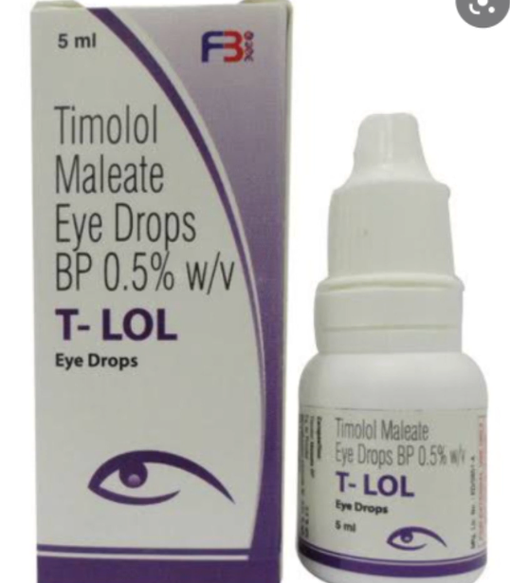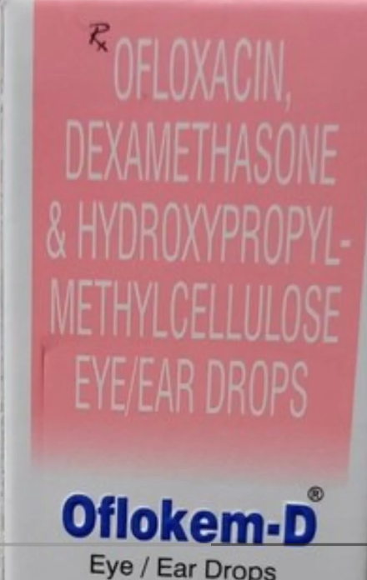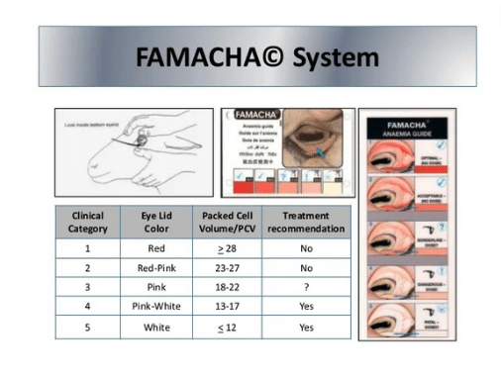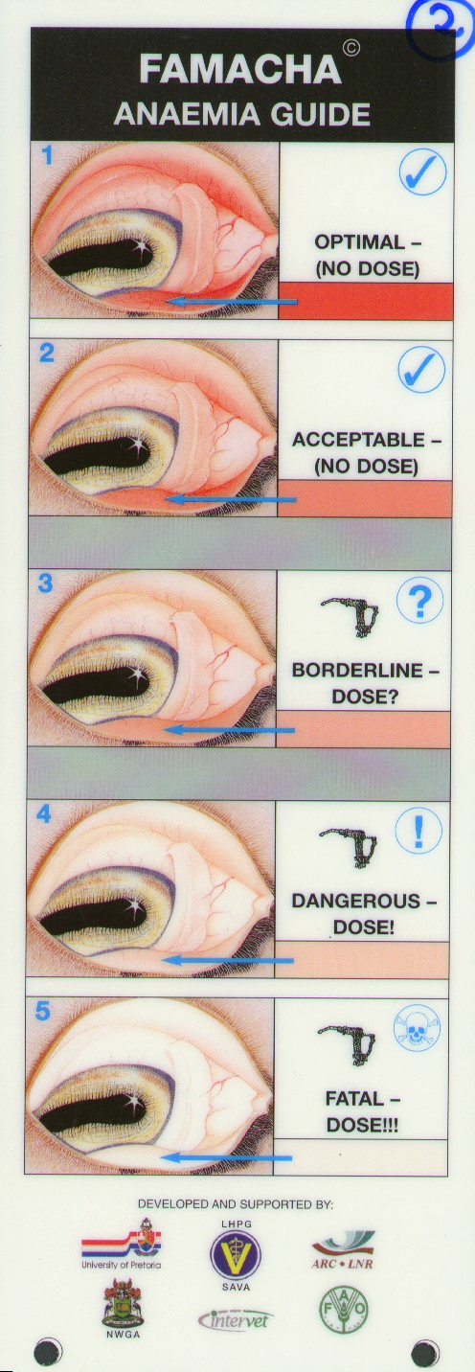

### **How to Use FAMACHA**

1. **Restrain the animal safely.**
2. **Pull down the lower eyelid** gently to expose the inner membrane.
3. **Compare the color** to the FAMACHA chart (usually a 1–5 scale):
   * **1 (Red)** – Healthy, no anemia
   * **2 (Slightly pale)** – Mild anemia
   * **3 (Moderate pale)** – Moderate anemia, consider treatment
   * **4 (Pale)** – Severe anemia, treat immediately
   * **5 (Very pale/white)** – Very severe anemia, urgent treatment needed
4. **Record the score** for each animal.

##### **Eye problems**

## **STEP 1: FIRST ACTION (FOR EVERY CASE – NO EXCEPTION)**

✔ **Isolate the animal**  
✔ **Stop sudden feed changes**  
✔ **Give ORS / electrolytes** (2–3 times daily)  
✔ **Provide clean drinking water**  
✔ **Keep lambs warm & dry**

⚠ Dehydration kills faster than diarrhea.

### **D. PARASITIC DIARRHEA**

**Signs**

* Pale eyelids
* Bottle jaw
* Weight loss

**Treatment**

* Deworm based on cause
* Use **ONLY ONE dewormer**
* Support with iron + vitamins

### **E. BLOODY DIARRHEA (EMERGENCY)**

**Cause**

* Coccidiosis (common in lambs)

**Action**  
⚠ **Immediate veterinary treatment required**

### **B. BACTERIAL / VIRAL DIARRHEA**

**Signs**

* Fever
* Foul smell
* Dull / weak animal
* Watery stool

### **First Line**

💉 **Sulphadiazine + Trimethoprim**  
(BIOSULPHA Injection)  
➕ **ZEET Injection**  
✔ As per label dose

### **If Not Cured in 48 Hours**

💉 **Levofloxacin Injection**  
(MERIFLOX Inj)

### **Or (Without Injection)**

💊 **Ofloxacin + Ornidazole Bolus** (Vet use)

**Loose Motions in Sheep**

## **STEP 2: IDENTIFY THE TYPE (MOST IMPORTANT)**

### **A. Feed Change / Indigestion Diarrhea**

**Signs**

* No fever
* Animal alert
* Green / loose stool
* Recent feed change

**Treatment**

* Correct feed gradually
* ORS only
* Probiotics if available  
  🚫 **NO antibiotics**

## **STEP 3: SUPPORTIVE CARE (ESSENTIAL)**

✔ ORS daily  
✔ Vitamin B-complex  
✔ Easy digestible feed  
✔ Clean housing  
✔ Monitor appetite & hydration

### **C. DIARRHEA IN LAMBS / SMALL KIDS**

💊 **Ciprofloxacin + Tinidazole** (Vet formulation)

### **Very Small / Weak Lambs**

💊 **Levofloxacin Hemihydrate + Ornidazole + Alpha Tocopherol**  
✔ Gentle and supportive

**Medicine images and Videos are**

**available in website**

##### **Miscellaneous**

